Supplementary Materials

Table S1. Mean and standard deviation scores for ADHD symptoms and global impairment.

|  |  |  |
| --- | --- | --- |
| **ADHD Variables** | **Mean** | **Standard Deviation** |
| 1/Careless | 1.01 | 0.784 |
| 2/Inattention | 0.93 | 0.777 |
| 3/Listen | 0.69 | 0.750 |
| 4/Instruction | 0.83 | 0.810 |
| 5/Disorganized | 0.88 | 0.790 |
| 6/Unmotivated | 0.76 | 0.816 |
| 7/Lose | 0.72 | 0.750 |
| 8/Distracted | 0.95 | 0.805 |
| 9/Forgetful | 0.83 | 0.749 |
| 10/Fidget | 0.57 | 0.801 |
| 11/Seat | 0.54 | 0.726 |
| 12/Run | 0.38 | 0.654 |
| 13/Quiet | 0.48 | 0.691 |
| 14/Motor | 0.55 | 0.746 |
| 15/Talk | 0.56 | 0.768 |
| 16/Blurt | 0.57 | 0.721 |
| 17/Wait | 0.57 | 0.722 |
| 18/Interrupt | 0.61 | 0.745 |
| Global Impairment | 79.57 | 12.130 |

Table S2. Relations of symptoms, with effect sizes, within and across the ADHD domains.

|  |  |  |
| --- | --- | --- |
| **Within IA Symptoms** | **Within HI Symptoms** | **Between IA with HI Symptoms** |
| Positive large effect size associations | | |
| “careless” with “inattention”;  “distracted” with “forgetful”. | “motor” with ‘talk’;  “talk” with “blurt’;  “blurt” with “wait”. | nil |
| Positive medium effect size associations | | |
| “careless” with “instruction”;  “listen” with “instruction”. | “seat” with “run”;  “run with quiet”;  “wait” with “interrupt”. | IA “listen” with HI “quiet”. |
| Positive small effect size associations | | |
| “careless” with “disorganized”;  “inattention” with “distracted”;  “instruction” with “distracted”;  “disorganized” with “avoids tasks”.  “avoids tasks” with “lose’ and “forgetful”;  “lose” with “forgetful”. | “fidgets” with “seat”, and “interrupt”;  “seat” with “motor”;  “run” with “wait”. | IA “listen” with HI “run”;  IA “avoids tasks” with HI run;  IA “lose” with HI “wait”. |
| Positive negligible effect size associations | | |
| “careless” with “lose”;  “inattention” with “listen”, “instruction”, “disorganized”, “avoids tasks”,  “lose” and forgetful”;  “listen” with “lose” and “forgetful”;  “instruction” with “disorganized”, “avoids tasks” and “lose”;  “disorganized” with “lose” and “forgetful”;  “lose” with “distracted”. | “fidget” with “quiet”, “motor”, “talk”, & “blurt”;  “seat” with “talk”, “blurt”, & “interrupt”;  “run” with “motor”;  “quite” with “motor” and “blurt”;  “motor” with “wait” and “interrupt”;  “talk” with “interrupt”;  “blurt” with “interrupt”. | IA “careless” with HI “fidget” and “talk”;  IA “inattention” with HI “wait”;  IA “listening” with HI “seat”, “blurt” & “wait”;  IA “instruction” with HI “interrupt”;  IA “disorganized” with HI “fidget”, “seat”, “talk” & “blurt”;  IA “avoids task” with HI “fidget”, “motor” & “interrupt”;  IA “lose” with HI “fidget”, “run”, “quiet” & “motor”;  IA “distracted” with HI “fidget”, “motor” & “blurt”;  IA “forgetful” with HI “fidget”, “seat”, ‘run” & “quiet”. |
| Negative negligible effect size associations | | |
| “careless” with “avoids tasks”;  “listening with “distracted”. | “fidget” with “wait”;  “run” with “blurt”;  “quiet” with “interrupt”;  “motor” with “blurt”;  “talk” with “wait”. | IA “careless” with HI “quiet”, “motor” & “interrupt”;  IA “inattention” with HI “fidget”, “run”, “blurt” & “interrupt”;  IA “listen” with HI “fidget” & “interrupt”;  IA “instruction” with HI “talk” & “wait”;  IA “disorganized” with HI “run”, “motor” & “wait”;  IA “avoids task” with HI “blurt”;  IA “lose” with HI “talk”;  IA “distracted” with HI “run” and “quiet”;  IA “forgetful’ with HI “wait”. |

Table S3. Details of edge weights in the network.

|  |
| --- |
| Within IA Symptoms  Table 2 shows that for the IA symptoms, there were positive large effect size associations for “careless” with “inattention”, and “distracted” with “forgetful”; positive medium effect size associations for “careless” with “instruction”, and “listen” with “instruction”; and positive small effect size associations for “careless” with “disorganized”; “inattention” with “distracted”; “instruction” with “distracted”; “disorganized” with “avoids tasks”; “avoids tasks” with “lose” and “forgetful”; and “lose” with “forgetful”. There were also positive negligible effect size associations for “careless” with “lose”; “inattention” with “listen”, “instruction”, “disorganized”, “avoids tasks”, “lose” and” forgetful”; “listen” with “lose” and “forgetful”; “instruction” with “disorganized”, “avoids tasks” and “lose”; “disorganized” with “lose” and “forgetful”; “lose” with “distracted”. There were also negative negligible effect size associations for “careless” with “avoids tasks”; and “listening with “distracted”. Overall, for the IA symptoms there were two positive edges of large effect size and two positive edges of moderate effect sizes. Thus 8.89% of nodes had positive effect sizes that were considered important and worthy of interpretation. There were 7 and 17 positive edges that had small and negligible effect sizes, respectively. Thus, when small and negligible effects are taken into consideration there were 25 (2 + 2 + 7 + 17 = 28) positive edges that were significant, or 62.22% (28/45) of edges that were theoretically meaningful. |
| Within HI Symptoms  For the HI symptoms, there were positive large effect size associations for “motor” with “talk”; “talk” with “blurt”; and “blurt” with “wait”. There were positive medium effect size associations for “seat” with “run”; “run with quiet”; and “wait” with “interrupt”. There were positive small effect size associations for “fidgets” with “seat”, and “interrupt”; “seat” with “motor”; and “run” with “wait”. There were positive negligible effect size associations for “fidget” with “quiet”, “motor”, “talk”, and “blurt”; “seat” with “talk”, “blurt”, and “interrupt”; “run” with “motor”; “quite” with “motor” and “blurt”; “motor” with “wait” and “interrupt”; “talk” with “interrupt”; and “blurt” with “interrupt”. There were also negative negligible effect size associations for “fidget” with “wait”; “run” with “blurt”; “quiet” with “interrupt”; “motor” with “blurt”; and “talk” with “wait”. Overall, therefore for the HI symptoms there were three positive edges of large effect size, and three positive edges of moderate effect size. Thus, 13.33% of nodes had positive effect sizes considered important and worthy of interpretation. There were 4 and 14 positive edges that had small and negligible effect sizes, respectively. Thus, when small and negligible effects are taken into consideration there were 23 (3 + 3 + 4 + 14 = 24) positive edges that were significant, or 53.33% (24/45) of edges that were theoretically meaningful. |
| Between IA with HI Symptoms  As shown in Table 2, there were no large effect size association for any of the IA symptoms with any of the HI symptoms. There was a positive medium effect size association for IA “listen” with HI “quiet”; and positive small effect size associations for IA “listen” with HI “run”; IA “avoids tasks” with HI run; and IA “lose” with HI “wait”. There were also positive negligible effect size associations for IA “careless” with HI “fidget” and “talk”; IA “inattention” with HI “wait”; IA “listening” with HI “seat”, “blurt” and “wait”; IA “instruction” with HI “interrupt”; IA “disorganized” with HI “fidget”, “seat”, “talk” and “blurt”; IA “avoids task” with HI “fidget”, “motor” and “interrupt”; IA “lose” with HI “fidget”, “run”, “quiet” and “motor”; IA “distracted” with HI “fidget”, “motor” and “blurt”; and IA “forgetful” with HI “fidget”, “seat”, “run” and “quiet”. There were also negative negligible effect size associations for IA “careless” with HI “quiet”, “motor” and “interrupt”; IA “inattention” with HI “fidget”, “run”, “blurt” and “interrupt”; IA “listen” with HI “fidget” and “interrupt”; IA “instruction” with HI “talk” and “wait”; IA “disorganized” with HI “run” , “motor” and “wait”; IA “avoids task” with HI “blurt”; IA “lose” with HI “talk”; IA “distracted” with HI “run” and “quiet”; and IA “forgetful” with HI “wait”. Overall, therefore, for the edges between the IA and HY symptoms, there was no edge of large effect size and only one edge of positive moderate effect size. Thus, 2.22% of nodes had positive effect sizes that were considered important and worthy of interpretation. There were 3 and 25 positive edges that had small and negligible effect sizes, respectively. Thus, when small and negligible effects are taken into consideration there were 29 (1 + 3 + 25 = 29) positive edges that were significant, or 35.50% of edges that were theoretically meaningful. |

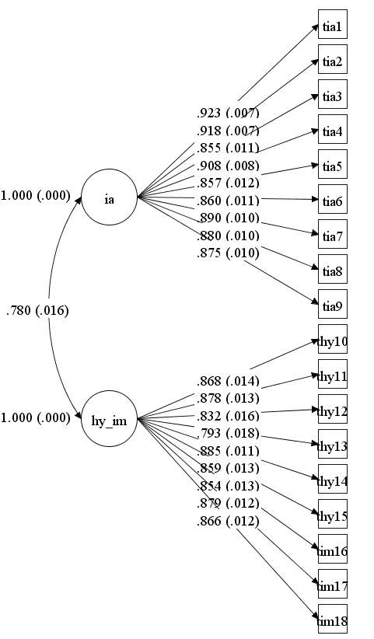

Figure S1. Standardized item factor loadings for the ADHD symptoms in the oblique 2-factor ADHD model. Note: IA = inattention latent factor; HY_IM = Hyperactivity/impulsivity latent factor; TIA = inattention symptoms; THY = hyperactivity symptoms; TIM = impulsivity symptoms.

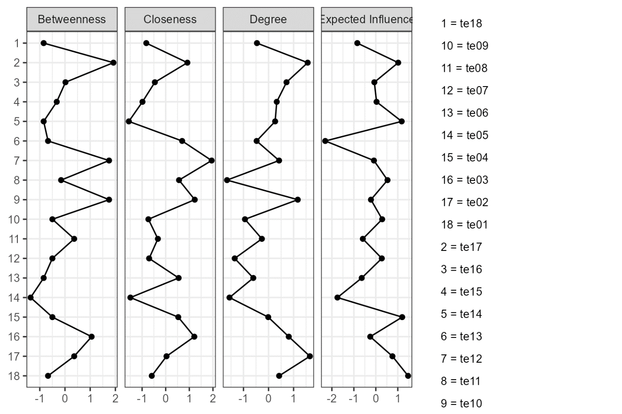

Figure S2. Centrality plots illustrating betweenness, closeness, degree, and expected influence values within the network. Note: values shown on the x-axis are standardized z-scores. See Table 1 for brief descriptions of the nodes.

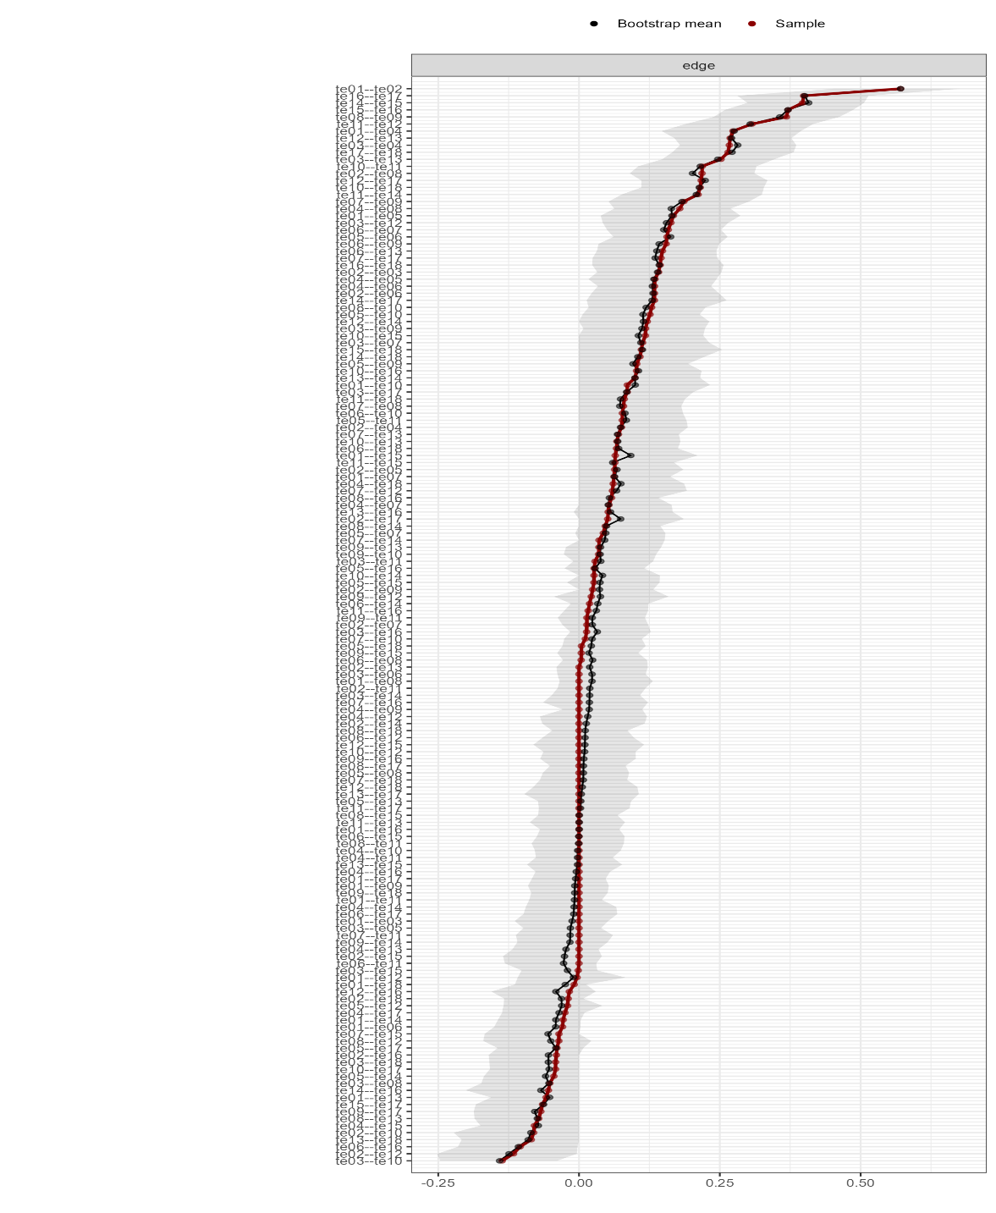

Figure S3. Edge stability estimate for the ADHD symptoms—tested using non-parametric bootstrapped estimate. Note: The x-axis represents the edges, while every line on the y-axis represents a specific edge. The red line shows the estimate of the edge weights, and the grey bars the 95% confidence intervals for the estimates.

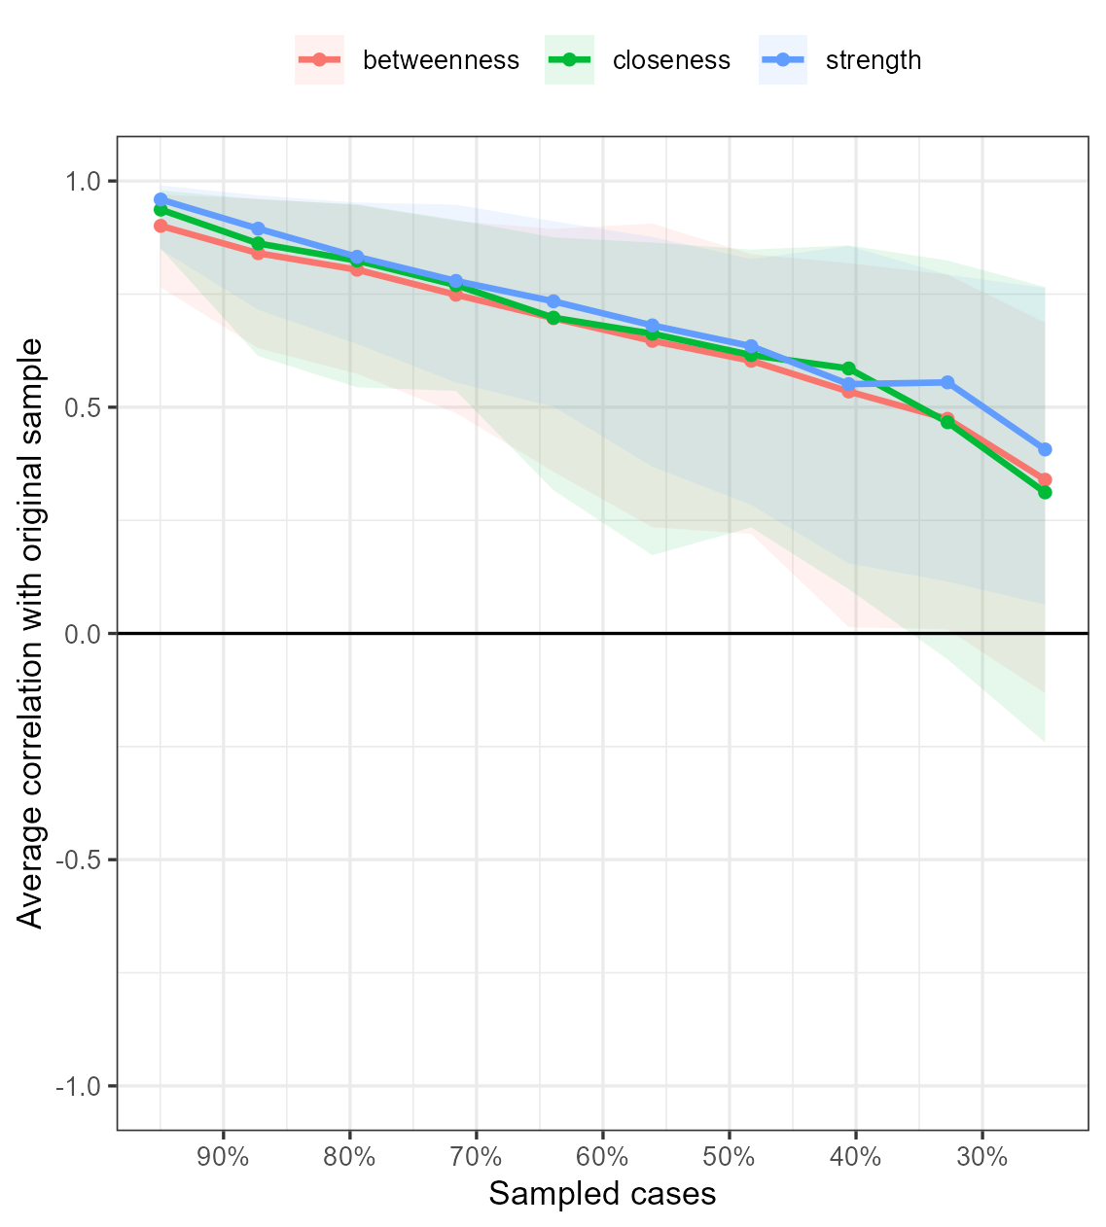

Figure S4. Stability of central indices for the ADHD symptoms. Note: The graph shows the average correlation between bootstrap centrality indices of networks sampled with node-dropping and the network of ADHD symptoms.